**5.ReactJS – HOL**

**1. Understanding the Need for Styling React Components**

**Why style React components?**

* To make the UI look good and user-friendly
* To apply custom colors, fonts, spacing, etc.
* To give each component its own look and feel
* Helps in reusing and organizing styles neatly
* Ensures responsive design (works well on mobile and desktop)

**2. Working with CSS Module and Inline Styles**

**A. CSS Modules**

* A way to write CSS specific to a component
* Prevents class name conflicts (CSS is scoped locally)
* File extension: .module.css

**How to use:**

// File: MyComponent.module.css

.title {

color: blue;

font-size: 20px;

}

// File: MyComponent.js

import styles from './MyComponent.module.css';

function MyComponent() {

return <h1 className={styles.title}>Hello, Priii!</h1>;

}

Style is modular and safe — only used in that component.

**B. Inline Styles**

* Style directly in the JSX using JavaScript object
* Good for quick or dynamic styling

**How to use:**

function MyComponent() {

const headingStyle = {

color: "green",

fontSize: "18px"

};

return <h2 style={headingStyle}>Welcome to React!</h2>;

}

Quick and no need for external CSS files  
 Not ideal for large stylesheets

**React Application :**

1. Unzip the react application in a folder
2. Open command prompt and switch to the react application folder
3. Restore the node packages using the following commands

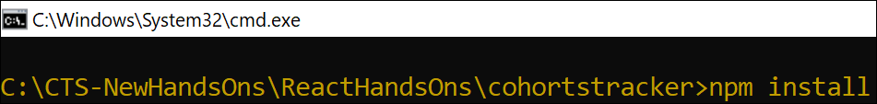

*Figure 1: Restore packages*

1. Open the application using VS Code
2. Create a new CSS Module in a file called “CohortDetails.module.css”
3. Define a css class with the name as “box” with following properties

*Width = 300px;*

*Display = inline block;*

*Overall 10px margin*

*Top and bottom padding as 10px*

*Left and right padding as 20px*

*1 px border in black color*

*A border radius of 10px*

1. Define a css style for html <dt> element using tag selector. Set the font weight to 500.
2. Open the cohort details component and import the CSS Module
3. Apply the box class to the container div
4. Define the style for <h3> element to use “green” color font when cohort status is “ongoing” and “blue” color in all other scenarios.

**Final Output:**

